Fi-Foil Company, Inc. November 2025
PO Box 800
Auburndale, Florida 33823
Toll Free 800-448-3401
Phone 863-965-1846
Fax 863-967-0137
Website www.fifoil.com
E-mail marketing@fifoil.com

Product Guide Specification
Specifier Notes: This product guide specification is written according to the Construction Specifications Institute (CSI) 3-Part Format, including MasterFormat, SectionFormat, and PageFormat, as described in The CSI Construction Specifications Practice Guide.
This section must be carefully reviewed and edited by the Architect to meet the requirements of the project and local building code. Coordinate this section with other specification sections and the Drawings. Delete all “Specifier Notes” after editing this section.
Section numbers and titles are based on MasterFormat 2020 Update.

07 21 53

REFLECTIVE BUBBLE INSULATION
Specifier Notes: This section covers FI-FOIL® RetroShield® System reflective bubble insulation intended for use in roofs and walls. Consult Fi-Foil Company for assistance in editing this section for the specific application.
  - GENERAL
    - SECTION INCLUDES
      - Reflective bubble insulation.
    - RELATED REQUIREMENTS
Specifier Notes: Edit the following list of related sections as necessary. Limit the list to sections with specific information that the reader might expect to find in this section but is specified elsewhere.
      - Section 06 11 00 – Wood Framing.
      - Section 07 26 00 – Vapor Retarders.
      - Section 07 27 00 – Air Barriers.
      - Section 09 22 13 – Metal Furring.
      - Section 13 34 19 – Metal Building Systems
    - REFERENCE STANDARDS
Specifier Notes: List reference standards used elsewhere in this section, complete with designations and titles.
      - ASTM C411 – Standard Test Method for Hot-Surface Performance of High-Temperature Thermal Insulation.
      - ASTM C518 – Standard Test Method for Steady-State Thermal Transmission Properties by Means of the Heat Flow Meter Apparatus.
      - ASTM C727 – Standard Practice for Installation and Use of Reflective Insulation in Building Constructions.
      - ASTM C1224 – Standard Specification for Reflective Insulation for Building Applications.
      - ASTM C1258 – Standard Test Method for Elevated Temperature and Humidity Resistance of Vapor Retarders for Insulation.
      - ASTM C1338 – Standard Test Method for Determining Fungi Resistance of Insulation Materials and Facings.
      - ASTM C1371 – Standard Test Method for Determination of Emittance of Materials Near Room Temperature Using Portable Emissometers.
      - ASTM D882 – Standard Test Method for Tensile Properties of Thin Plastic Sheeting.
      - ASTM D2261 – Standard Test Method for Tearing Strength of Fabrics by the Tongue (Single Rip) Procedure (Constant-Rate-of-Extension Tensile Testing Machine).
      - ASTM E84 – Standard Test Method for Surface Burning Characteristics of Building Materials.
      - ASTM E96 – Standard Test Methods for Water Vapor Transmission of Materials.
      - ASTM E2599 – Standard Practice for Specimen Preparation and Mounting of Reflective Insulation, Radiant Barrier and Vinyl Stretch Ceiling Materials for Building Applications to Assess Surface Burning Characteristics.
      - ASTM G154 – Standard Practice for Operating Fluorescent Ultraviolet (UV) Lamp Apparatus for Exposure of Materials.
    - SUBMITTALS
Specifier Notes: Edit submittal requirements as necessary. Delete submittals not required.
      - Comply with Section 01 33 00 – Submittal Procedures.
      - Product Data: Submit manufacturer’s product data, including installation instructions.
      - Samples: Submit manufacturer’s samples.
        - Reflective bubble insulation, minimum 6 inches square.
        - Clip and pin components.
      - Manufacturer’s Certification: Submit manufacturer’s certification that materials comply with specified requirements and are suitable for intended application.
      - Sustainable Design Submittals: Submit manufacturer’s sustainable design submittals.
        - Recycled Content: Certify percentages of pre-consumer and post-consumer recycled content.
      - Warranty Documentation: Submit manufacturer’s standard warranty.
    - DELIVERY, STORAGE, AND HANDLING
      - Delivery Requirements: Deliver materials to site in manufacturer’s original, unopened containers and packaging, with labels clearly identifying product name and manufacturer.
      - Storage and Handling Requirements:
        - Store and handle materials in accordance with manufacturer’s instructions.
        - Keep materials in manufacturer’s original, unopened containers and packaging until installation.
        - Store materials in clean, dry area indoors.
        - Protect materials during storage, handling, and installation to prevent damage.
  - PRODUCTS
    - MANUFACTURERS
      - Manufacturer: Fi-Foil Company, Inc., PO Box 800, Auburndale, Florida 33823. Toll Free 800-448-3401. Phone 863-965-1846. Fax 863-967-0137. Website. E-mail marketing@fifoil.com.
Specifier Notes: Specify if substitutions will be permitted.
      - Substitutions: [Not permitted] [In accordance with Division 1].
    - REFLECTIVE BUBBLE INSULATION
      - Reflective Bubble Insulation: FI-FOIL® “RetroShield® System”.
      - Description:
        - Reflective Bubble Insulation.
        - Nominal Thickness: 5/16” (double bubble) and 3/16” (single bubble).
Specifier Notes: Specify facings.
        - Facings: [Metalized film on both sides] [Metalized film on one side and white polyethylene on other side].
        - Edges: Integrated tape tab.
        - Antioxidants: Contains antioxidants to reduce impact of ultraviolet radiation and oxidation.
      - Compliance and Approvals:
        - State of California Bureau of Furnishings and Thermal Insulation License #T390, updated 9/08/2025 (RBI Shield™ Reflective Foil/Foil and Reflective Foil/White).
        - Certified by IAPMO ES ER-291.
        - Verified by RIMA #US-012-10.
      - Testing:
        - Water Vapor Permeance, ASTM E96: ≤1.0 perms
        - Temp & Humidity Resistance, ASTM C1258: No corrosion or delamination.
        - Pliability, ASTM C1224: No cracking or delamination.
        - Bleeding and Delamination, ASTM C1224: No bleeding or delamination.
        - Fungi Resistance, ASTM C1338: Pass.
        - Thermal Emittance, ASTM C1371: 0.06
        - Hot Surface Performance, ASTM C411: <250 degrees Fahrenheit, for Reflective/Reflective only. Note: Not for use in direct contact on surfaces that exceed 180 degrees Fahrenheit.
        - UV Exposure, ASTM G154: 105% Retention after 2k hrs, for Reflective/White only.
        - Flammability, ASTM E84 in accordance with E2599:
          - Reflective/Reflective:
            - Flame Spread: 0.
            - Smoke Developed: <50.
            - Classification: Class A.
          - Reflective/White:
            - Flame Spread: 0.
            - Smoke Developed: <50.
            - Classification: Class A
        - Tensile Strength, ASTM D882: Pass, for Reflective/White only.
        - Tear Resistance (MD), ASTM D2261:
          - RWDB: 13.26 lbƒ/IN²
          - RRDB: 11.56 lbƒ/IN²
          - RWSB: 9.42 lbƒ/IN²
          - RRSB: 8.62 lbƒ/IN²
        - Tear Resistance (AMD), ASTM D2261:
          - RWDB: 14.23 lbƒ/IN²
          - RRDB: 16.95 lbƒ/IN²
          - RWSB: 9.66 lbƒ/IN²
          - RRSB: 10.32 lbƒ/IN²
      - R-Values, in accordance with ASTM C1224 under C518 and C1371, verified by R&D Services, Inc. Report: RD25911 Aug 18, 2025. Note: R-values include lower air film.

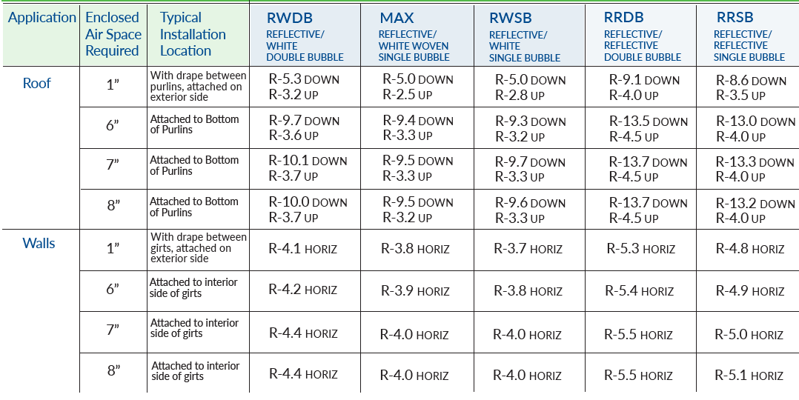
    - ACCESSORIES
Specifier Notes: Delete accessories not required.
      - Clip-Pin and Washer Components:
        - Description: Use with tape tab, reflective bubble insulation for metal building and framing applications to provide secure mechanical connections.
        - Beam or Bar Joist Clip (Z): For beams, bar joists, or Z-type purlins.
        - Purlin Clip (C): For C-type purlins.
        - Angle Clip (L): For sidewalls and floors.
        - Tube Clips (U): For wood beams or metal beams. Available in 2-inch x 1-inch or 4-inch by 1-inch.
        - Locking Washers: White or Silver to match reflective bubble insulation facing color.
        - Material: Electro Galvanized Steel Fasteners.
      - Polyester PET Tape: ECHO tape PE-M4535 [Silver] [White] or comparable product.
        - Description: White, polyester PET film coated with cold weather acrylic adhesive.
        - Width: 1.89 inches.
        - Thickness: 3.38 mils.
        - Adhesion: 60 oz/inch width.
        - Tensile Strength: 20 lbs/inch width.
        - Surface Temperature: Minus 40 to-plus 148 deg F (Minus 20 to plus 40 deg C).
      - Double Sided Tape: 3M™ Venture Tape™ Double Coated Tape 1163 or equivalent.
        - Description: 0.5-mil polyester film coated on both sides with 3-mil acrylic adhesive.
        - Width: 3/4 inch.
        - Temperature Resistance: Minus 40 degrees F to 200 degrees F (minus 40 degrees C to 93 degrees C).
  - EXECUTION
    - EXAMINATION
      - Examine areas to receive reflective bubble insulation.
      - Notify Architect of conditions that would adversely affect installation.
      - Do not begin installation until unacceptable conditions are corrected.
    - INSTALLATION
      - Install reflective bubble insulation in accordance with manufacturer's instructions and ASTM C727.
      - Install reflective bubble insulation at locations indicated on the Drawings.
      - Seal joints in reflective bubble insulation with integrated tape tab or with manufacture-approved foil or poly tape.
      - Replace damaged reflective bubble insulation as directed by Architect.
    - PROTECTION
      - Protect installed reflective bubble insulation from damage during construction.

END OF SECTION

